Basic queries

SELECT *
FROM volunteers;
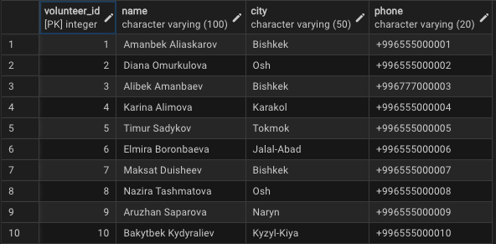

SELECT name, city, phone
FROM volunteers
WHERE city = 'Bishkek'
ORDER BY name;


SELECT event_id, title, event_date, location
FROM events
WHERE event_date >= '2025-04-01'
ORDER BY event_date;
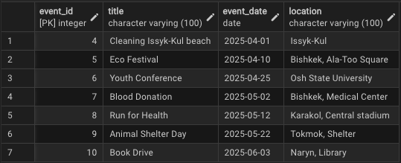

SELECT
e.title,
e.event_date,
o.name AS organization_name
FROM events e
JOIN organizations o ON e.organization_id = o.organization_id
ORDER BY e.event_date;


SELECT city, COUNT(*) AS volunteers_count
FROM volunteers
GROUP BY city
ORDER BY volunteers_count DESC;
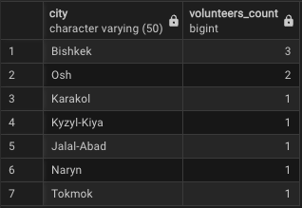

SELECT
v.name AS volunteer_name,
e.title AS event_title,
e.event_date,
p.hours_worked
FROM participation p
JOIN volunteers v ON p.volunteer_id = v.volunteer_id
JOIN events e ON p.event_id = e.event_id
ORDER BY e.event_date, v.name;

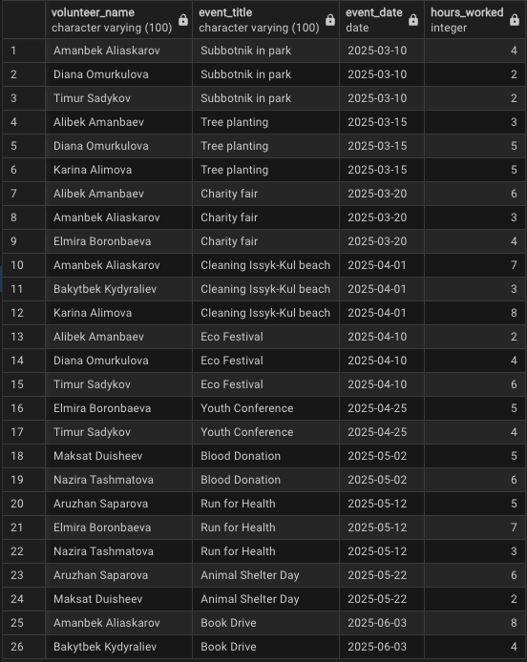

SELECT
v.name,
SUM(p.hours_worked) AS total_hours
FROM participation p
JOIN volunteers v ON p.volunteer_id = v.volunteer_id
GROUP BY v.name
ORDER BY total_hours DESC;
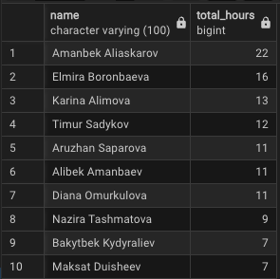

SELECT
o.name AS organization_name,
COUNT(e.event_id) AS events_count
FROM organizations o
LEFT JOIN events e ON o.organization_id = e.organization_id
GROUP BY o.name
HAVING COUNT(e.event_id) > 1
ORDER BY events_count DESC;



SELECT
v.name,
SUM(p.hours_worked) AS total_hours
FROM participation p
JOIN volunteers v ON p.volunteer_id = v.volunteer_id
GROUP BY v.name
HAVING SUM(p.hours_worked) >
(
SELECT AVG(total_hours_sub)
FROM (
SELECT SUM(hours_worked) AS total_hours_sub
FROM participation
GROUP BY volunteer_id
) AS t
);
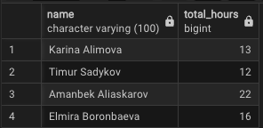

WITH event_hours AS (
SELECT
e.event_id,
e.title,
SUM(p.hours_worked) AS total_hours
FROM events e
LEFT JOIN participation p ON e.event_id = p.event_id
GROUP BY e.event_id, e.title
)
SELECT *
FROM event_hours
ORDER BY total_hours DESC NULLS LAST;
